**ls /etc/kubernetes/manifests**

Location for yaml files for the pods.

You just create the YAML file. No need to run any command, pod will create automatically.

If any YAML file is deleted, then corresponding pod will be deleted.

**how many ways you can create an K8s pod?**

07:18 run, create, YAML, Deployments, statefulset Static pod( /etc/kuberenetes/manifests), Daemonsets, bare pod, replica-set pod, helm

Pod, replicaset, deployment, services,

statefulsets,

Daemonsets,

static path

**How to check the static pod location?**

ps -ef | grep static

--config= /etc/kubernetes/manifests

**How to schedule pods and probe?**

Note:

Whenever we give an instruction to create a pod to the master node. Scheduler from master node will decide to schedule the pod in node01/node02,.. location.

**pod Scheduling;**

We can decide this pod must be run on node01.

If node01 is not available, then it will be in pending stage.

**Scheduling the pods:**

1. NodeName Only Node name

2. NodeSelector All Labels names must be matched. else it will be in pending stage.

3. PodAffinity inside a node atleast single pod must be run + labels must be matched.

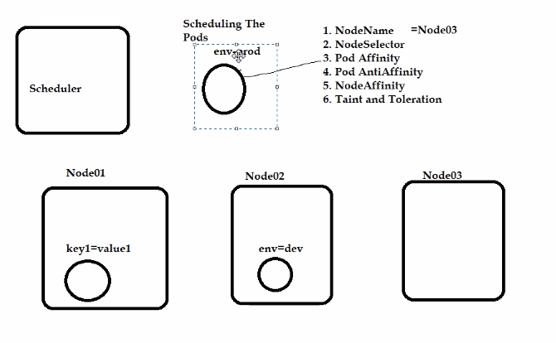

4. Pod AntiAffinity Exactly opp to pod affinity. i.e., pod must be run on any node + labels must not be matched.

5. NodeAffinity

preferedDuringSchedulingIgnoredDuringExecution

requiredDuringSchedulingIgnoredDuringExecution is same as nodeselector

6. Taint and Toleration

Node Selector Vs NodeAffinity

Pod Affinity

**Maintanence**

**Cordon, drain, evicted, created**

**Moving pod from one node to another node**

Kubectl cordon <node01>

Cordon => Once it is cordon, new pods won’t deploy in this node. So no new pods will be deploy in node01.

**19-10-23**

**Pod Phases (Life Cycle)**

Pending, running, succeeded, Failed, unknown, Completed